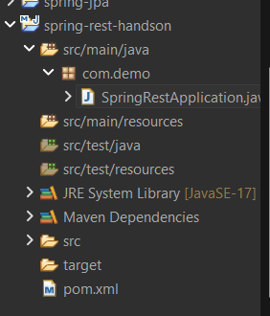

<project xmlns="http://maven.apache.org/POM/4.0.0"
xmlns:xsi="http://www.w3.org/2001/XMLSchema-instance"
xsi:schemaLocation="http://maven.apache.org/POM/4.0.0 https://maven.apache.org/xsd/maven-4.0.0.xsd">

<modelVersion>4.0.0</modelVersion>

<parent>
<groupId>org.springframework.boot</groupId>
<artifactId>spring-boot-starter-parent</artifactId>
<version>3.2.0</version>
</parent>

<groupId>com.demo</groupId>
<artifactId>spring-rest-handson</artifactId>
<version>0.0.1-SNAPSHOT</version>

<properties>
<java.version>17</java.version>
</properties>

<dependencies>

<!-- Spring Boot Web -->
<dependency>
<groupId>org.springframework.boot</groupId>
<artifactId>spring-boot-starter-web</artifactId>
</dependency>

</dependencies>

</project>

package com.demo;

import org.springframework.boot.SpringApplication;
import org.springframework.boot.autoconfigure.SpringBootApplication;

@SpringBootApplication
public class SpringRestApplication {

public static void main(String[] args) {
SpringApplication.run(SpringRestApplication.class, args);
}
}

OUTPUT:
